



ML Ops & Containerization
LAB MANUAL

Disclaimer: The content is curated from online/offline resources and used for educational purpose only
Managing Project Versions Using Git – Online Food Ordering System
Objective
To learn how Git maintains multiple project versions by committing feature updates throughout software development.
Problem Statement
A development team is creating an Online Food Ordering System. New features such as menus, customer ordering, and payment processing are added in different stages. Git is required to maintain each development milestone.
Requirements
Software
- Git
- Visual Studio Code
Files
- README.md
- food_order.py
Procedure
Step 1: Create Project
mkdir FoodOrderingSystem
cd FoodOrderingSystem
git init
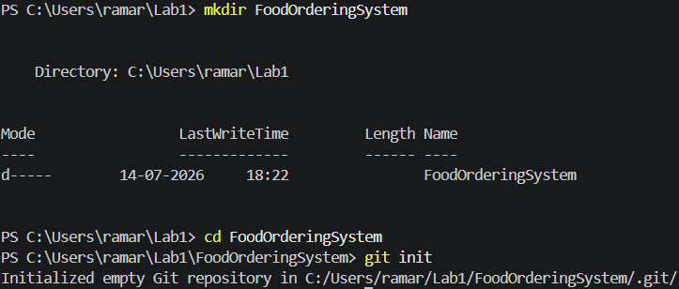

Step 2: Create README.md
# Online Food Ordering System
# Author
Your Name

Step 3: Create food_order.py
print("Welcome to Online Food Ordering")

Step 4: Commit Version 1
git add .
git commit -m "Version 1 - Project created"
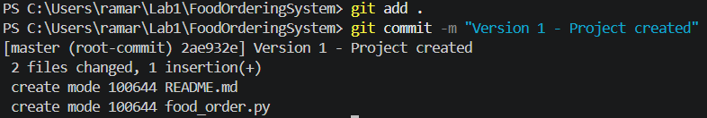

Step 5: Add Menu Feature
menu = ["Pizza","Burger","Pasta"]
print(menu)

Step 6: Commit Version 2
git add .
git commit -m "Version 2 - Added food menu"
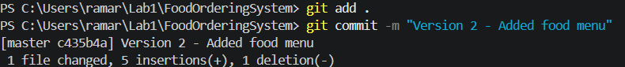
Step 7: Add Customer Order
choice = input("Enter food item: ")
print("Order placed:", choice)

Step 8: Commit Version 3
git add .
git commit -m "Version 3 - Added ordering feature"
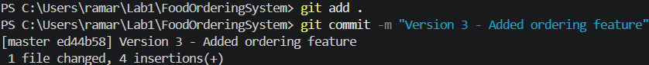
Step 9: View Complete History
git log --oneline
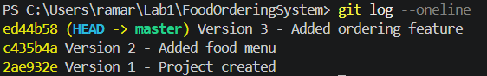
Step 10: Display Detailed History
git log
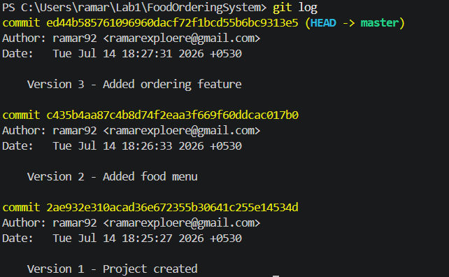
Conclusion
Students learned how Git records multiple software versions, enabling developers to track feature additions, review project history, and manage software development efficiently through version control.

